Hanish Patel

HW 1

CS 471-01

Report for hw 1

**Abstract**

Examinate and understand how virtual machines work. Use Ubuntu as an operating system for the virtual machine. Experiment with the virtual machine in a simulated environment. Observe the installation and simple commands for updating and validation.

**Introduction**

Ubuntu will be used for the virtual machine. Ubuntu will be set up and installed.

We will use this command for updating Ubuntu.

sudo apt-get update

We will install those updates with the following command:

sudo apt-get upgrade

We will also use this command to obtain system information:

uname -a

We will obtain more information about commands by using the manual:

man (before the command)

**Summary of Results**

Start by downloading opening virtual box and have an Ubuntu image ready.

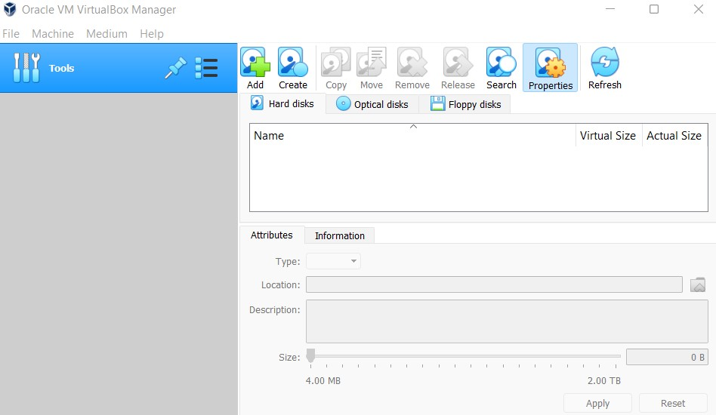

Now create a new virtual machine and configure settings in virtual box.

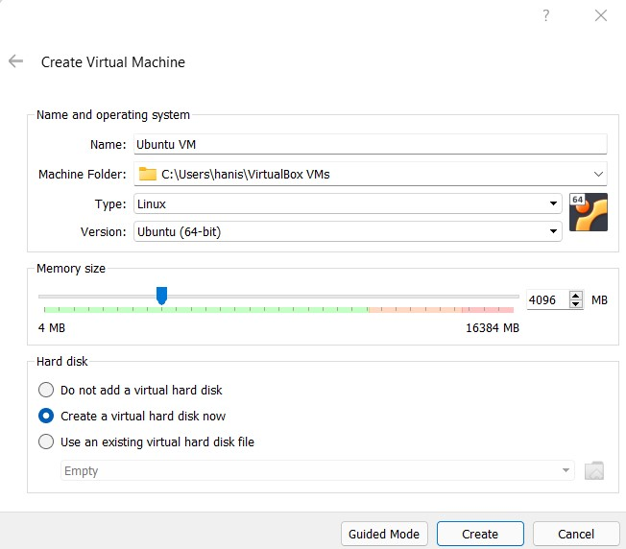

We now select some more options.

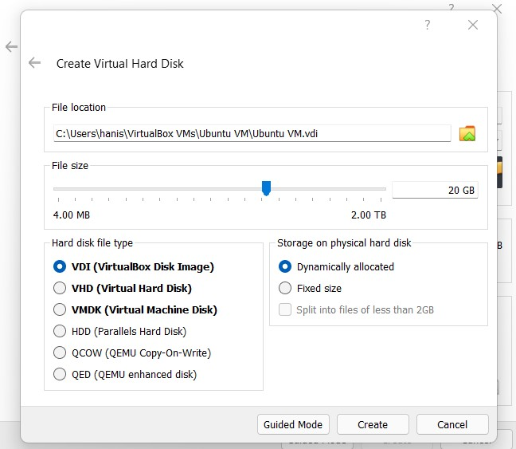

To use the Ubuntu image, we want to make sure the VM is using the iso file. We can click the blue disc and select our iso file to set up the disc image.

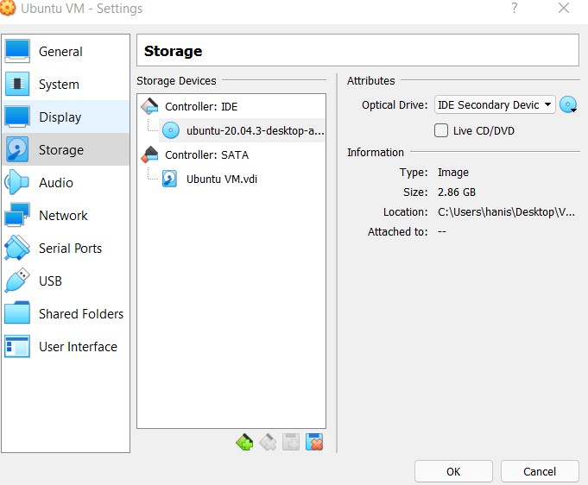

We can now run this, and we are prompted with an installation.

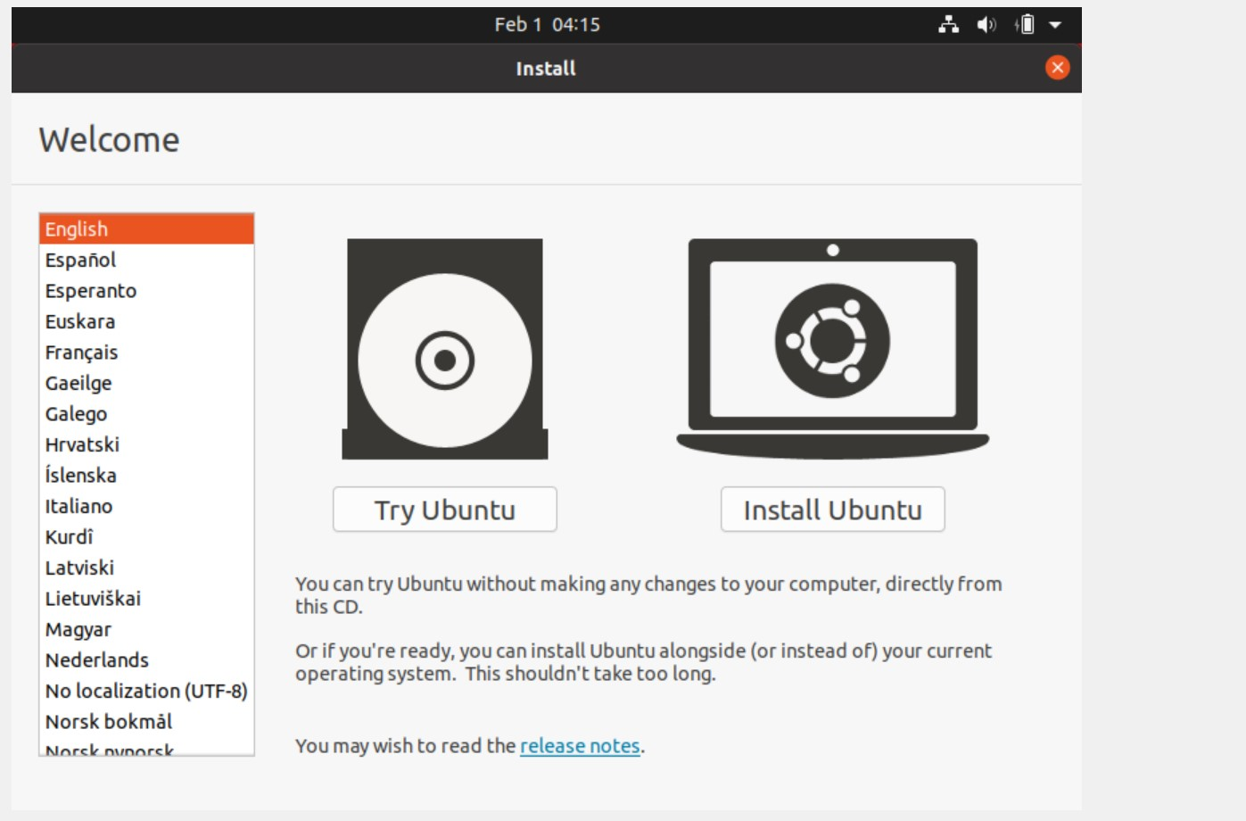

We can keep selecting next and install all our ubuntu files and our keyboard, time-zone and other preferences. We will now be able to see the desktop after the installation finishes.

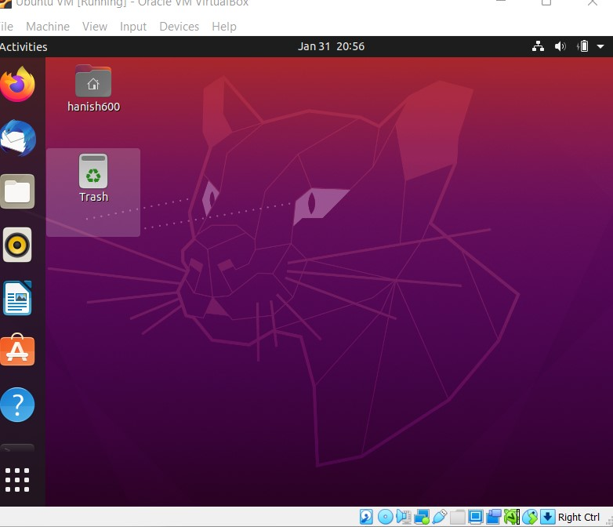

We can click on the six white dots and navigate to the terminal. After doing so, we can run the command for validating our Ubuntu.

This is done by using: uname -a.

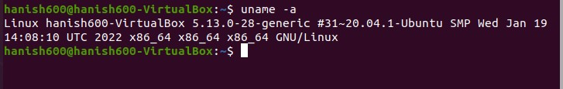

We can now see the manual for how uname works by typing man before uname.

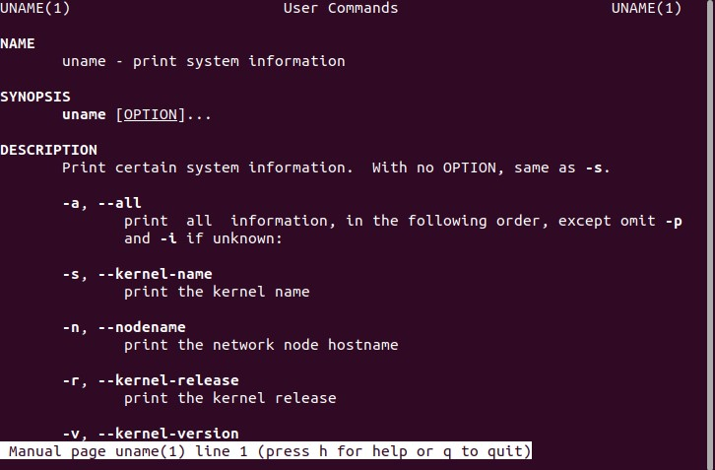

As we can see, uname prints out system information, and -a prints all system information. We can now run sudo apt-get update to fetch updates.

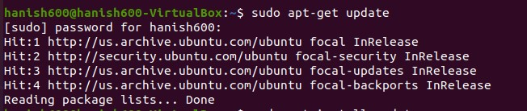

We can upgrade all these packages with sudo apt-get install upgrade. This is to make sure our Ubuntu runs much smoother and is not buggy and we have necessary tools and services.

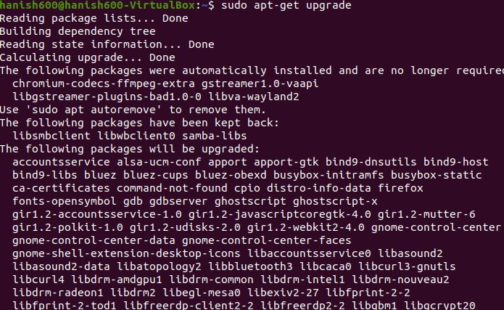

**Conclusion**

During a live file system iso, there is temporary storage. This is unsaved. The installation on a virtual hard drive does not cause storage to be lost. This is important because the live file system iso ensures that the storage is cleaned while the virtual hard drive ensure future use of data. It is important to use the right one so data isn’t lost and also so that data isn’t occupying space. A good application for a live file system iso would be to simply do some browsing without needing to save any bookmarks or passwords. A good application for a virtual hard drive is to store some programs and documents that may be used later on.